Rutgers Business School
33:136:370 Management Information Systems
Instructor: Disha Parkhi
Following are the examples for Subtype relationship (Chapter 4)

4.18: Musical Instrument Dealer: You operate a business that buys, sells, and repairs bowed musical instruments such as violins, violas, cellos, and acoustic basses. You consider anybody who either sells an instrument from you or buys one from you to be a “customer.” Most of the stock you deal in are mass‐produced models, but a few are extremely expensive antique instruments. Due to your volume of business, you are moving from paper record‐keeping to a relational database. For each customer, you want the new system to store a customer title (Dr., Prof., Mr., Ms., etc.), first name, middle name/initial, last name, address information, phone number, and e‐mail address. For each instrument you deal with, you want to store its type (violin, cello, etc.), manufacturer, year of manufacture, model (if any), and serial number (if any). Most modern producers of instruments assign a model name and serial number to each instrument they make, but some small artisanal and older classic instrument producers do not. Of the thousands of instruments that pass through your business each year, a small percentage are classic instruments that have “provenance” information describing their history. When an instrument has such information, you want the database to store a provenance summary that you will enter in a 255‐character text field. You also want to track transactions involving each instrument. It is common for you to sell an instrument (for example, to a student) and then buy it back again. For each transaction, you need to record a code indicating whether it was a purchase or a sale, which instrument was involved, which customer was involved, the date, and the price. Sometimes, you perform minor repair work on instruments using your own in‐house staff. For each repair, you want to record which instrument was involved, the date, and a description of the repair. Design a database to hold all this information. You may create synthetic keys as necessary or convenient. If possible, avoid having blank provenance fields for instruments not needing provenance information.

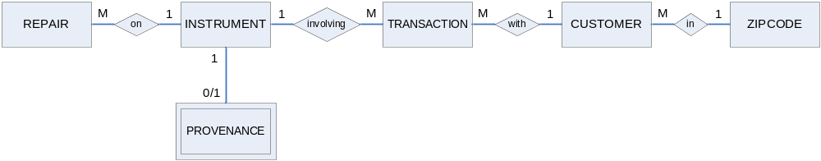
ZIPCODE(Zip, City, State)
CUSTOMER(CustomerID, Title, FirstName, MiddlenameInitial, LastName,
Address, Zip, Phone, Email)
Zip foreign key to ZIPCODE
INSTRUMENT(InstrumentID, Type, Manufacturer, Year, ModelName, SerialNumber)
REPAIR(RepairID, InstrumentID, Date, Description)
InstrumentID foreign key to INSTRUMENT
TRANSACTION(TransactionID, BuyOrSell, InstrumentID, CustomerID, Price)
InstrumentID foreign key to INSTRUMENT
CustomerID foreign key to CUSTOMER
PROVENANCE(InstrumentID, ProvenanceSummary)
InstrumentID foreign key to INSTRUMENT
None of the tables had obvious primary keys, so synthetic keys are shown for all of them. If all manufacturers gave their instrument serial numbers, (Manufacturer, SerialNumber) would have been a possible primary key for INSTRUMENT. But since small or old manufacturers do not necessarily provide serial numbers, that is not an option.

4.20 County real estate records: You are creating an electronic version of the records of your county’s register of deeds. The county has a number of municipalities (towns, villages, cities, etc.), and for each one you want to store a name, a type (city, township, borough, etc.), and date of incorporation. Each municipality has numerous buildings, each of which is identified by a block number and lot number (each building within a given municipality has a unique combination of block number and lot number). For each building, you want to store a street address, zip code, and the year in which it was constructed. Note that zip codes do not correspond perfectly to municipalities: some municipalities have multiple zip codes, and the boundaries of zip codes and municipalities are not perfectly aligned. Each building may have been sold many times; for each sale, you want to record its price, date, and the name of the person or company the building was sold to (you record owners’ names using a single, long “name” field because some owners are corporations). Finally, a small percentage of buildings in the county are in the national register of historic places; for these buildings, you want to record a 255‐ character description of the unique features of the building, the date it was inducted into the historic register, and the ID number the register assigned to it. Assume that you have access to a data table that includes the zip code and corresponding post office name for each zip code that intersects the county; include this table in your database (all these zip codes are in the same state as your county, so the state need not be stored). Set up your database so that the records for non‐historic buildings do not have to store empty fields for historic‐register‐related data.

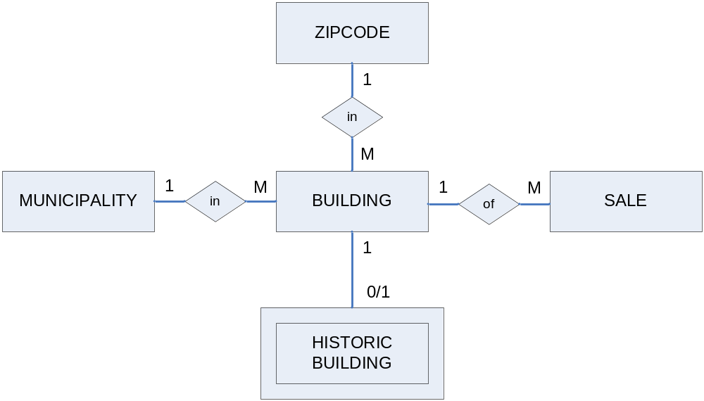

MUNICIPALITY(MuniID, Name, Type, DateIncorporated)
BUILDING(BuildingID, MuniID, Block, Lot, StreetAddress, Zip, ConstructionYear)
MuniID foreign key to MUNICIPALITY
Zip foreign key to ZIPCODE
HISTORICBUILDING(BuildingID, UniqueFeaturesDescrip, RegisterNumber, DateInducted)
BuildingID foreign key to BUILDING
SALE(SaleId, BuildingID, Price, Date, BuyerName)
BuildingID foreign key to BUILDING
ZIPCODE(Zip, PostOfficeName)

Note that HISTORICBUILDING is a subtype of BUILDING, with the same primary key and a foreign key to BUILDING. This design uses synthetic keys throughout for simplicity. You could also use a composite key of (MuniID, Block, Lot) for BUILDING, since each block-lot combination is unique within each municipality. However, this approach would require a matching three-part composite key in HISTORICBUILDING, and a three-part foreign key in SALE. While they are possible, we have so far avoided such constructions in class.

